Dynamic xpath and findElements

First screenshot explains, howDynamic ID handle using: contains, starts-with, ends-with functions.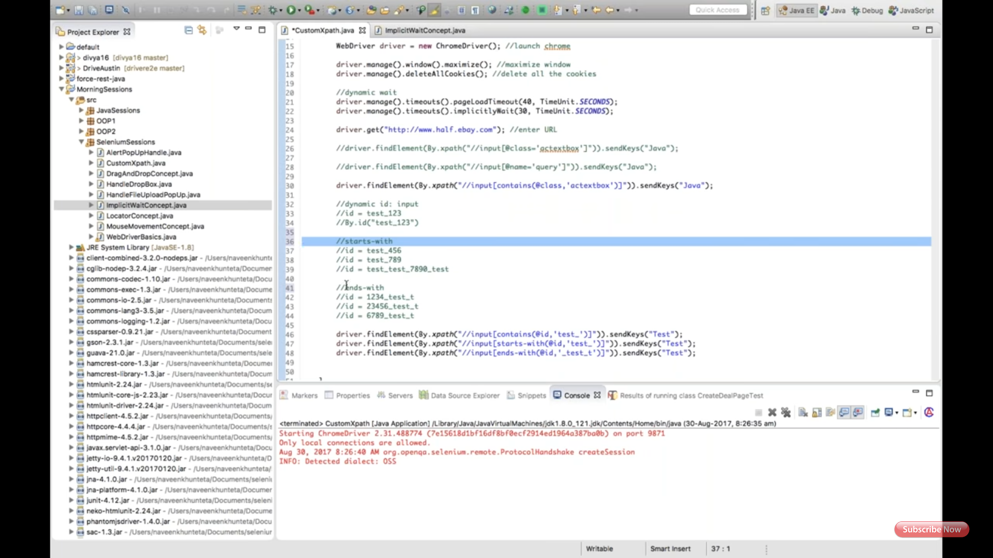

Second screenshot explains, findElements and getting count of total links and it's texts. Using List<WebElements> and for loop ll.get(i).get text();

